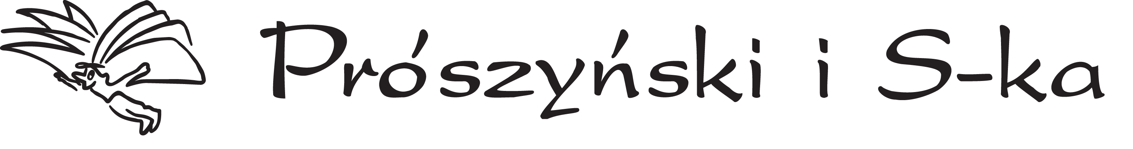

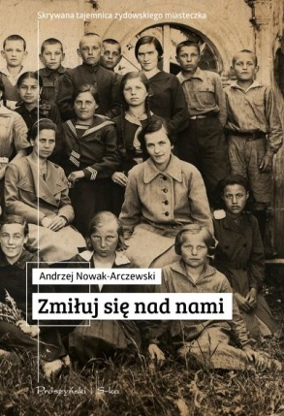

Book details
Zmiłuj się nad nami, reportage
Prószyński Media 2017
256 pages
ISBN 978-83-8097-040-3
Publication date: 24.01.2017
227 200 characters

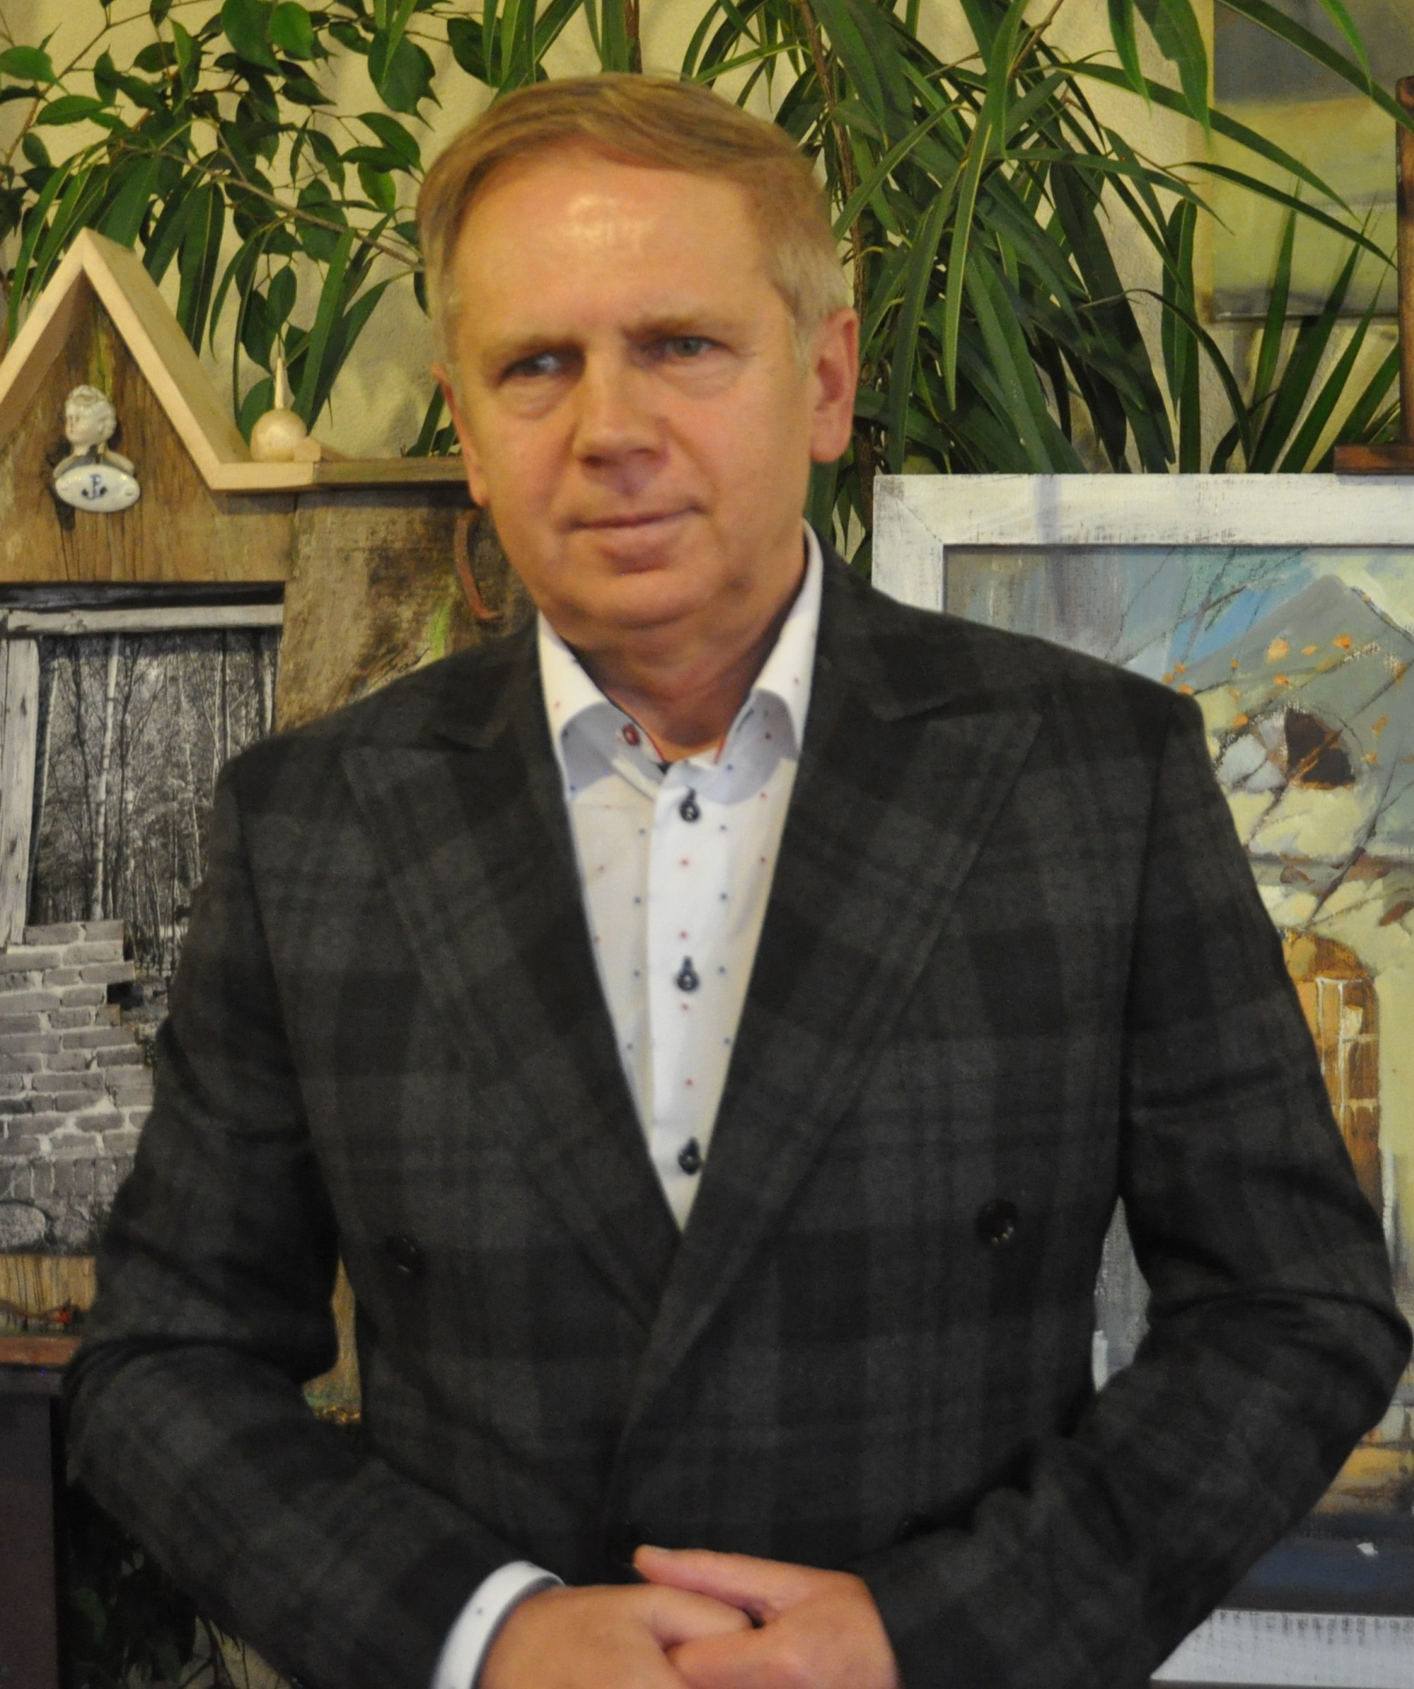
ANDRZEJ NOWAK-ARCZEWSKI
HAVE MERCY UPON US

This is a reporter’s story about the mystery of a Jewish town.
A town like many others in Poland. A murder of Jewish neighbors. A mystery that no stranger should discover even today. What happens to people who shut themselves from the outside world?
This is not another book about pogroms. This is not an attempt to look for the guilty. It is a story about the mechanisms of memory in a small town, involving the extermination of Jews.
Klimontów, a small town near Sandomierz, is a witness to many cruelties during the occupation. But this is not the end; immediately after the war some events leave a mark on the Poles. After many years, when everyone seems to have lost the truth - we return to the town. We visit the inhabitants who have occupied the houses of their former neighbors, and we want to hear the truth about those events. Only is it possible
to break this silence?

Andrzej Nowak-Arczewski – reporter, laureate of the Zbigniew Nosal National Competition for Reportage. He is the author of journalist books, including Orłowińska Ballad, We, From the Palace.

Kontakt
e-mail: rights@proszynskimedia.pl
e-mail: izabeladelesiewicz@proszynskimedia.pl
Prószyński Media Sp. z o.o., ul. Gintrowskiego 28, 02-697 Warszawa
www.proszynski.pl, www.facebook.com/proszynski

