"The Holocaust" of the Jews from Krzemieniec in the year 1942
Jerzy Strumiński
Published 1996 or later, Source Unknown
Translated from Polish by Grzegorz Gembala
25 November 2004
[Translation Editor’s Note: This apparently is a magazine or a book article, pages 21-25. It was written either in or shortly after 1996. Ronald D. Doctor received a copy of the article from Tamara Senina on a visit to Kremenets in September 2002. Unfortunately, the source is unknown.]
August of 1996 marks the fifty-fourth anniversary of the genocide committed on the more than a dozen thousand Jews from the Krzemieniec ghetto.
The author would like to pay homage to the victims of those tragic events. The article includes a fragment from Stanislaw Sheybal's "Memoirs", he has also been a witness of what went on in the ghetto on that day in August, watching the events from the building of the Krzemieniec High School, from the direction of the former Pierackiego Street.
This publication includes also the drawings of the city map of Krzemieniec, with the marked location of the ghetto, bordered by the streets Szeroka, Pierackiego and Korzeniewskiego, as well as the location of the old Jewish cemetery at the Kredowa (Chalk) hill on the first part of the map, and the second part of the map, marking the location of the genocide of the Jewish citizens at the former shooting ground on the road to the village Królewski Most, at the foot of the Kuliczówka hill.
x x x
The Nazis started to create a ghetto for the Jews shortly after taking over Krzemieniec in 1941. The area of the ghetto was located in the center of the town, inhabited mainly by Jewish families - bordered by the streets Szeroka from the east, Krzemienieckiego from the west, Pierackiego from the south and the area of the Fire Brigade from the north. Also Jews from other quarters of the town were moved to that area. The ghetto area has been surrounded with a fence, guarded by the military police and the Schutzmanns (the Ukrainian police, subordinate to the military police). More than a dozen thousand of Jews were locked up in the ghetto, including the refugees from the west, mostly from Łódź. The social structure was differentiated. Apart from a group of wealthy émigrés from Łódź, most of the population was made of poor people of the pre-war era. The Germans have set up a local self-government, the kehillah and the ordinal service, the Ordnungsdienst.
The food allotments for the ghetto, provided by the Germans, left the people, especially the poor ones, starving. In the initial period, the trade exchange between the ghetto and the surrounding areas was quite animated, due to many holes in the fence and through the groups of Jews leaving the ghetto to the locations of their forced work.
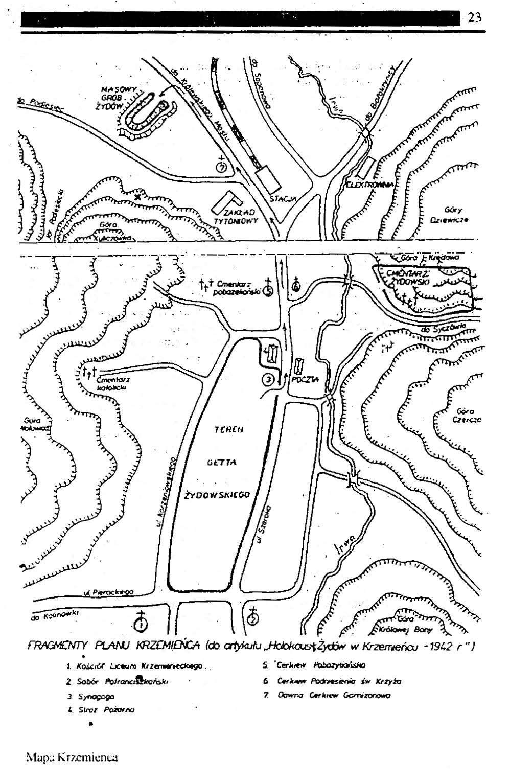
The first restriction, which has struck the ghetto, was the order of the Gebietskommissar to demolish the synagogue by the Jews themselves - which represented the religious center of the Jewish life. The synagogue in the Szeroka Street was a mighty structure. The bricks from the demolished synagogue were used for the construction of German buildings. Also the Jewish cemetery at the Kredowa hill has met the same fate, the headstones being taken away in masses.
The Gebietskommissar of Krzemieniec, a high-rank Nazi ruffian, realized quickly that the Jews of Krzemieniec might be deprived as well of their gold and other valuables. The Jews trusted in the power of the gold and silver and hoped to survive by giving it to the Germans. Whole carts of gold and later of silver, in different form e.g. candlesticks, boxes and other products, were taken from the ghetto. These supplies were however out soon.
In the summer of 1942, the Gebietskommissar has been sent away to attend a "well-deserved vacation". Another Nazi ruffian from the Gestapo replaced him. In the eyes of Himmler, he was appointed to fulfil an "honorable" task - the liquidation of the Krzemieniec ghetto. This is how it started. From now on, I will be just a chronicler.
The ghetto has been sealed off and surrounded by military policemen and the Schutzmanns. Then, a shooting started at random, which lasted for two days. The aim of this was the psychical breaking and treatment of the Jews prior to the Aktion, which was meant to take place.
During the shooting, the wealthiest Jewish families organized farewell dinners, which ended often in suicides by taking poison.
The random shooting of the ghetto area has brought few victims, but it has completely broken the instinct of self-preservation among the inhabitants of the ghetto. It has turned the people into "involuntary cattle being taken into slaughter". It was a beautiful, sunny day, when the gossip spread around that trucks with wooden structures carry the Jews from the ghetto somewhere in the direction of the Dubno turnpike. I've learnt from the inhabitants of downtown that trucks are entering through the main gate of the ghetto, and Jews are loaded onto them in masses, and then they drive away. The tragic of the situation was worsened by the fact that the Jewish police, armed with clubs, also participated in dragging the people from their homes and herding them to the square. The Nazis have most probably promised them that they can save their lives by doing this, the promise they finally didn't keep. They were taken to the site of the "holocaust" in the evening, in the last trucks. Around noon, news spread around that the shootings of the Jews take place at the end of the "Podlesiecki Gorge", under the western slopes of the Kuliczówka. Many people were going to the Kuliczówka and I've also joined them. From the hill one could see the "Dantean scenes" that took place at its foot (around 200 meters away, in straight line). The word "Dantean" is probably improper because what he had once described was a fantasy, whereas here, we saw the real crime of genocide of such magnitude, later described by the Hebrew word "Holocaust".
After the first shock caused by the scenes that happened at the foot of the hill, the human psychics has the strange property that it gets used to it with the time and registers the scenes that take place as a kind of macabre movie picture.
I will allow myself a digression and describe the site that has been chosen by the Nazis as the place of the mass execution. At the exit of the “Podlesiecki Gorge” (further down the road there is the so-called “Rotten Lake”, known for its skiing range), along the road from Krzemieniec to Mlynowiec upon Ikwa the former rifle-range of the Yakutian infantry regiment was located since the First World War. The rifle range was over 100 meters long and a couple dozen meters wide, with embankments from three sides, the access was free only from the side next to the road. On the area of this rifle range, a ditch, 8 – 10 meters wide and a couple dozen meters long had been prepared. Next to the excavated earth, there were barrels standing along the ditch, most probably filled with lime chloride. Armed military policemen and Schutzmanns were standing on the embankments. The extermination action took place in the area of the rifle range.
The process of the extermination was as follows: each arriving truck has been surrounded more than a dozen military policemen with whips. After unloading the people, they were driven to the so-called “dressing room”, where they had to undress to the nude and leave their clothes, which have been later thoroughly searched. Lots of gold, valuables and foreign currency have been found in them. Then, they were driven by the military policemen one by one to the execution ditch. In the ditch, two Gestapo men were “on duty” with their pistols. They fulfilled the “honorable task of Hitler and Himmler” by shooting their victims in the back of their heads. One could conclude from the example of the “holocaust” in Krzemieniec that Himmler’s “scientists” have developed a sophisticated method of killing people. In order to “rationally” utilize each square meter of the ditch, the victims have been killed and were falling on the bodies of the predecessors lying crosswise, which resulted in a much higher layer of bodies in the ditch than by laying them next to one another. The shot in the back of the head caused little outflow of blood (thus, the Gestapo henchmen didn’t have to paddle in blood). The empty space between the legs of the victims was filled by the military policemen with bodies of murdered children.
A few words about the henchmen: during the few hours of my stay on the slopes of Kuliczówka, six henchmen were “active” at the rifle range, two in each “shift”. While two were “working”, the other four were sitting at a table, crammed with food and bottles of vodka and they changed the “shifts” from time to time. There is no doubt that they were all drunk, and the accuracy of their shots was also problematic.
The fact that during the few hours of my observations there were only two cases of escape attempts proves the effectiveness of the methods of psychological abuse of humans. Young men, who have already been driven to the death ditch, have tried to escape. They started to run, jumped over the embankment of the rifle range and ran into the cornfields, surrounding the rifle range. Shots have been fired from the embankments. I don’t know whether they’ve managed to escape. Another example: one of the trucks, carrying the victims and their escort, overturned while turning in a very sharp curve. Everybody fell out. It was a magnificent chance to escape, however, nobody tried, and the military policemen drove the people with whips to the “dressing room”, and then to the death ditch.
As the ditch filled up, the “burial” took place. It consisted in spilling a white powder (most probably, lime chloride) onto the bodies, then the bodies were covered with a dozen-inch thick layer of earth. Under these circumstances, also those had to die, who have not been “offered” a sudden death by the drunken Gestapo men.
I will return for a moment to the extermination. As I mentioned before, one gets accustomed after a longer while to the observed atrocities, however scenes remain in the memory until the end of the days - such as a naked woman with one child in her hand and the second, older, holding her hand, being driven with whips to the ditch of extermination, or an old man with a long white beard, being driven to the same ditch.
The fact that the Germans tolerated the inhabitants of Krzemieniec, sitting on the slopes of Kuliczówka might have been on purpose – the aim was intimidation. I suppose that many of those sitting there (especially Poles) thought the same: today the Jews, and in a while, it will be us. Many of us were thinking: God, where are you? God, do you see that?!... On that day, approximately 10,000 Jews were killed. It was a beautiful, sunny day, and the sky was blue above their mass grave.
Finally, I would like to quote the memories of professor Scheybal, published in his book on pp. 278-281: “The mentality of many German intellectuals, both military and civilians, was astonishing, and one cannot explain it plainly by blaming the terror raging in the Third Reich. Even the well educated and cultured ones, often lovers and experts in music and art., were able to accept even the most brutal acts and monstrous crimes. May I allow myself to quote here a characteristic example, which took place in our photo shop. It happened during the inhuman liquidation of the Jewish inhabitants of the ghetto in Krzemieniec. The atmosphere in the town was terrible and depressing. The executions took place just out of the town and we saw the victims being driven away, all those local merchants, craftsmen, teachers, doctors and students we knew. One of the graduates of the Krzemieniec High School entered the photo shop, nervous and crying she told us that she has just seen a former classmate of hers, a Jewish girl, her friend, who has been driven on a truck to the execution site. They bid farewell to each other, by waving hands and with a sad smile. I’ve been trying to comfort her, when a German officer entered the photo shop, I knew that he was a lawyer. He was intelligent, always courteous and well mannered, a real esthete, compassionate and an expert in the values of the artistic photography. Seeing the crying girl, he asked with concern, what has happened to her. The girl popped out and started to shout at him with a hysteric, hoarse voice (she spoke perfectly German): “Don’t you know what happens? What are you doing with the Jews? You scoundrels, you cruel criminals, you bandits!”. The German was standing there, stunned and confused. Then he turned around and ran out of the photo shop. I was certain that he went to call the military policemen. I told the girl to run away at once and awaited with anxiety, how the matters will develop. However, nothing has happened on that day. The next day, the German officer came with a triumphant face and asked me about the whereabouts of that girl. I told him that I didn’t know her and that she must have been out of town. She just came to buy some postcards and after talking to the officer she left. He started to shout that he must find her and explain it to her. She said that the German nation is a nation of criminals and murderers. He called it a slander. He explained that he had checked everything personally – he went to the site of the execution and convinced himself that there was no cruelty. The Jews were walking quietly, nobody pushed or hit them, the shots were aimed perfectly so why did she talk about cruelty...
I was stunned. And the German probably recalled that he was a lawyer too. He said that unless someone would question the fact of getting rid of the Jews itself, and added, with slightly less conviction, that the will and the sake of the German nation represent the most superior law. This was probably the most horrible time during the German occupation. Shortly before the liquidation of the Jews, the news coming from the ghetto were terrible. One of our colleagues, who had been forced into the ghetto, a history teacher of Jewish origin, very popular among the young students, committed suicide on the very same day he had been appointed the head of the Jewish police. Another Jew whom we’ve known very well, an ophthalmologist, has poisoned his family – his wife and a couple of young children, and when he didn’t have enough poison to kill himself, he committed suicide by hanging himself.
During the liquidation of the Jews, through the window of the local museum, I have seen a scene that has frozen the blood in my veins. I won’t forget it until the end of my life. I could see a backyard of one of the Jewish houses, with a line of old and ill Jews lying there, men and women. Most probably, due to their infirmity, it would have been difficult to transport them to the execution site. Suddenly, a German officer entered the yard, wearing a snow-white overall, I recognized him, he was an elegant man, and he started to kill these people with single shots from his pistol, approaching each of them and pointing the pistol at the head. An NCO followed (I think he was a medic) and checked the effectiveness of the officer’s shots. Here and there, he “corrected”... and this was it.
On the evening of the same day, I’ve been sitting in our photo lab and the director of the local museum came to me (he was Ukrainian, an art historian). He told me that two young Germans came to visit, however, he can’t communicate with them and asked me for help as translator. The young men, whom I then met in the museum, introduced themselves politely, they have made the impression to be modest, intelligent and cultured young men, interested in the history of Ukrainian countryside.
The discussion concerning the museum exhibits lasted until midnight. During this conversation, I felt uneasy only once. When the director showed those men a skull with a hole and explained that the hole was made by a nail, which allows the conclusion that the victim was a convict. The Germans started to examine the hole with delight, laughing loudly. After they left, I’ve mentioned this unusual behavior to the director. The director asked me then: “Why do you wonder? Don’t you know who these young men were? They are the murderers of thousand of Jews. They’ve boasted to me that only today they have shot three hundred Jews during their “working hours”.
This reminded me of the words, I’ve heard from another young German soldier just a few weeks before, who declared that “he was ready to commit anything, previously considered to be a crime, by the order of the Fuhrer and that he would be proud to do this for the sake of the German nation”. He said also that “a true German cannot be a cry-baby and this is how they were taught and educated in the Hitlerjugend”.
Concluding my report, I will add a few words concerning the end of the ghetto in Krzemieniec. After the day of the mass killings, which cost the lives of approximately 10,000 Jews, the Nazis have penetrated the area of the ghetto for several weeks. During this time, they have taken away everything that was of any value e.g. furniture, clothing, bedclothes etc. During this time, one could hear single shots being fired from time to time, most probably the sounds of liquidation of the last hiding inhabitants of the ghetto.
Most probably around early September, fire was set to a number of the buildings of the ghetto. The fire raged for a number of days and everything that remained was ashes and ruins.
*****

