From Oholei Zadikim www.zadikim.org/

Translation by Marc Goldberger

Sensational discovery from the distant past...

Not long ago the Ohaley Tsadikim Association found the burial place and tombstone of Rabbi Avraham Hayot (Chajes) from Krakow, a great Tsadik. (the right stele).

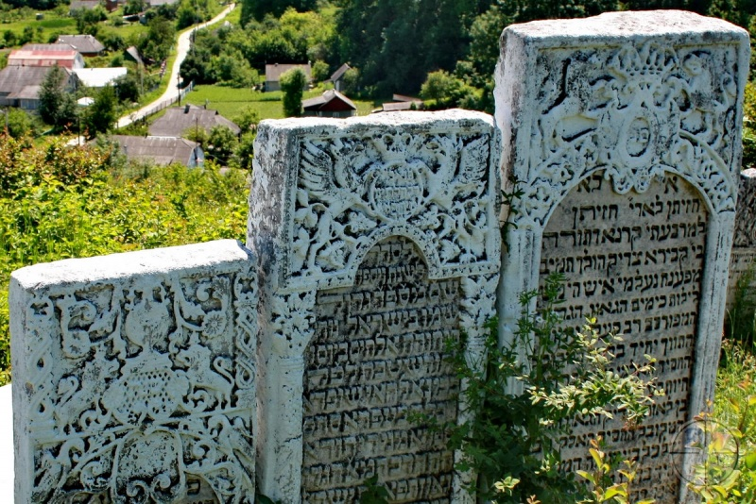

It is very important to note that his father Yitzhak Hayot (Chajes) (1538-1615) was one of the most important Jewish sages, who took place of honor among the intellectual giants of their generation. Rabbi Yitzhak Hayot is known as the Chief Rabbi of Prague.

Rabbi Yitzhak Hayot sister was married to Maharal from Prague (first wife).

Son, Rabbi Avraham Hayot from Krakow, was known as one of the highest spiritual thought giants of his generation, author of "Olech Tamim."

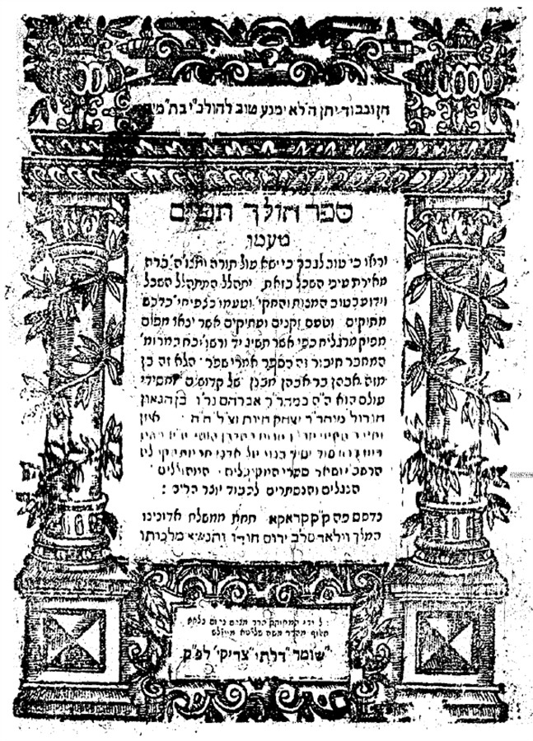

The book "Olech Tamim"
There were also found 7 tombstones of tsaddiks whose names are not known.
More about this and Hayot family tree you can read here in Hebrew: http://www.zadikim.org/42972.html
http://www.zadikim.org/42645.html

In Gorodok, an old Jewish cemetery survived where there are hundreds of tombstones, bearing a huge number of unique monuments from different eras. The earliest tomb dates back to the XVIII century, the latest – to the middle of the twentieth century. The cemetery is located on a round hill overlooking the city, and is overgrown with thick bushes. A considerable number of tombstones have carved decoration, close in style to the decor of the Jewish cemetery in Satanov.

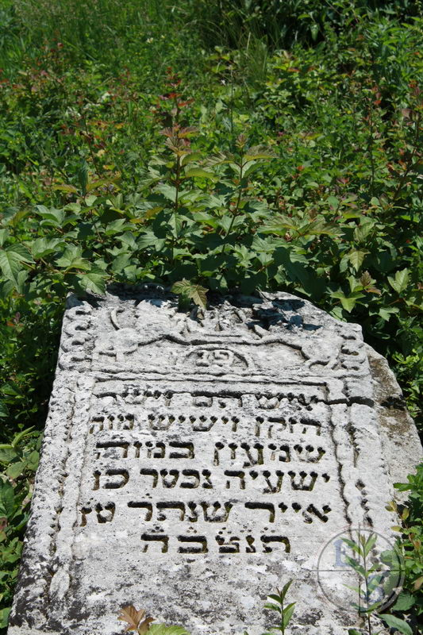

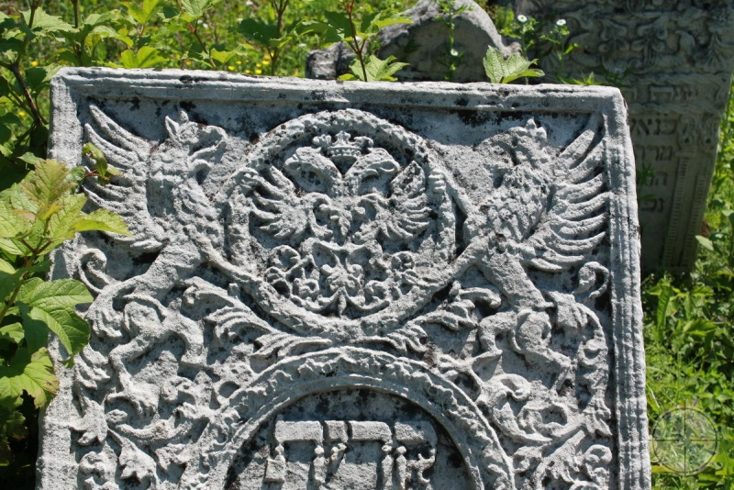

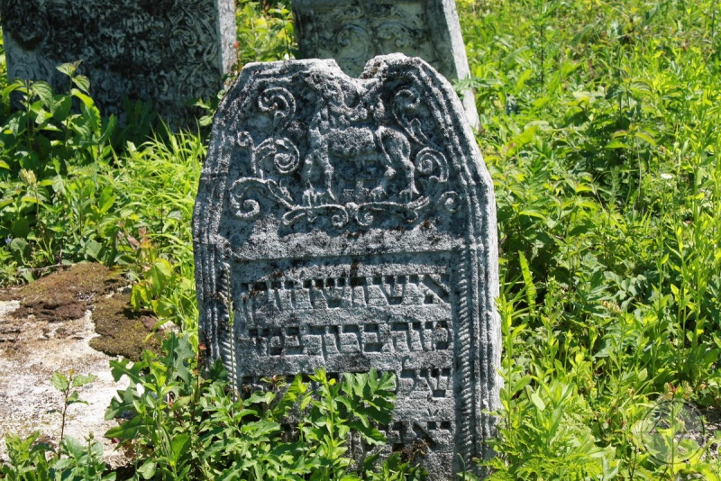
More pictures from the Jewish cemetery:
http://myshtetl.io.ua/album622963_0

http://photohunt.org.ua/Gorodok.html

http://gorodok-region.narod.ru/symvoly_j.html

http://gorodok-region.narod.ru/foto_n_04.html

